<CITY> is participating in the 20XX Community Visioning Program. Iowa State University is gathering information from community members to learn your opinions on how to improve the community’s landscape through transportation enhancements.
The goal of this project is to develop a landscape plan that illustrates the vision of <CITY>. Your input is an important part of this process and your ideas about community design and enhancement are valuable to the <CITY> visioning committee.
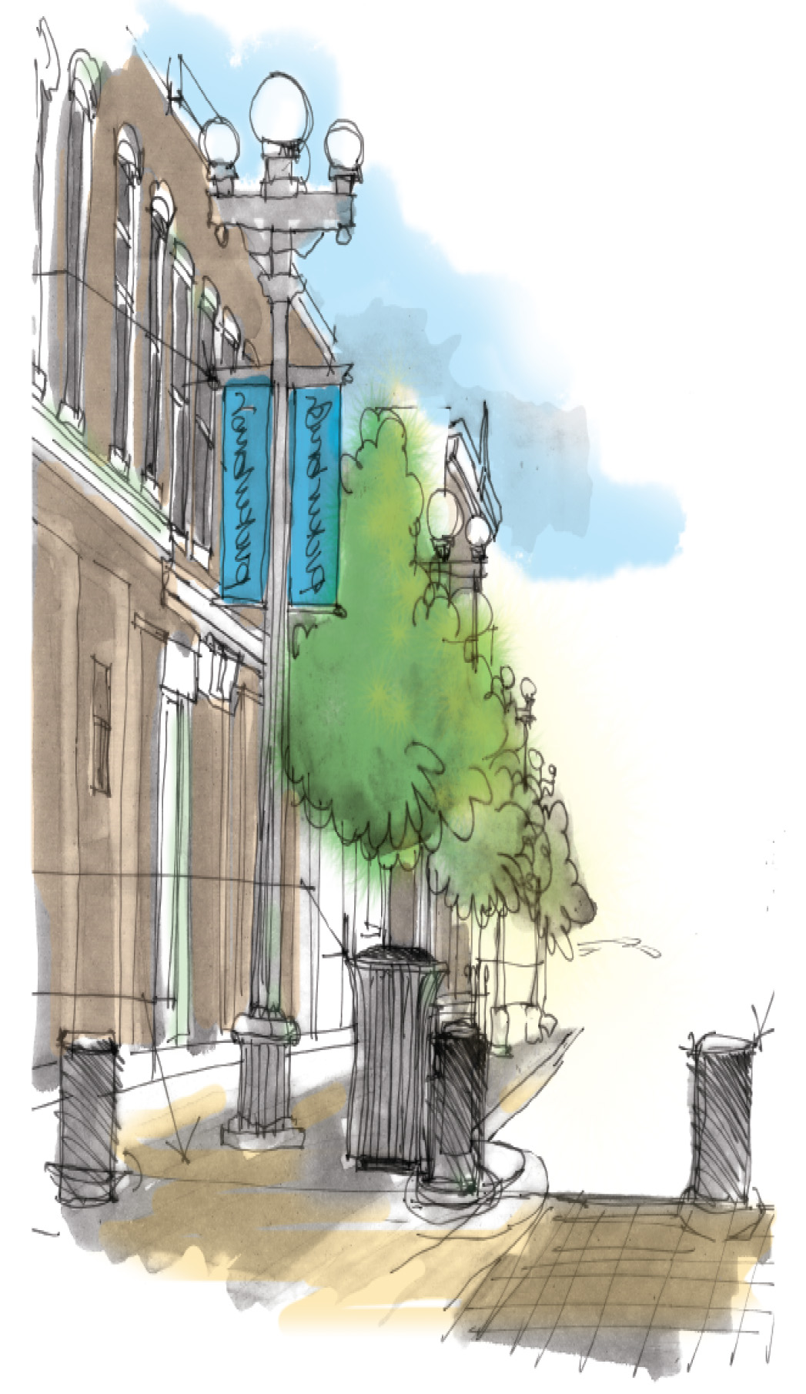
To sign up, visit www.communityvisioning.org/<CITY> and click on “Public Input.” We will meet <DAY, DATE>, at the following times:
<TIME>: Steering committee
<TIME>: Youth 13 and older
<TIME>: Active recreationists
<TIME>: Youth 12 and younger
<TIME>: Mobility challenged
<TIME>: Parents
<TIME>: Older adults (65 years old & older)
INSERT QR CODE

