<<COMMUNITY>> is participating in the <<YEAR>> Community Visioning Program. Iowa State University is gathering information from community members to learn your opinions on how to improve the community’s landscape through transportation enhancements.
The goal of this project is to develop a landscape plan that illustrates the vision of <<COMMUNITY>>. Your input is an important part of this process and your ideas about community design and enhancement are valuable to the <<COMMUNITY>> visioning committee.
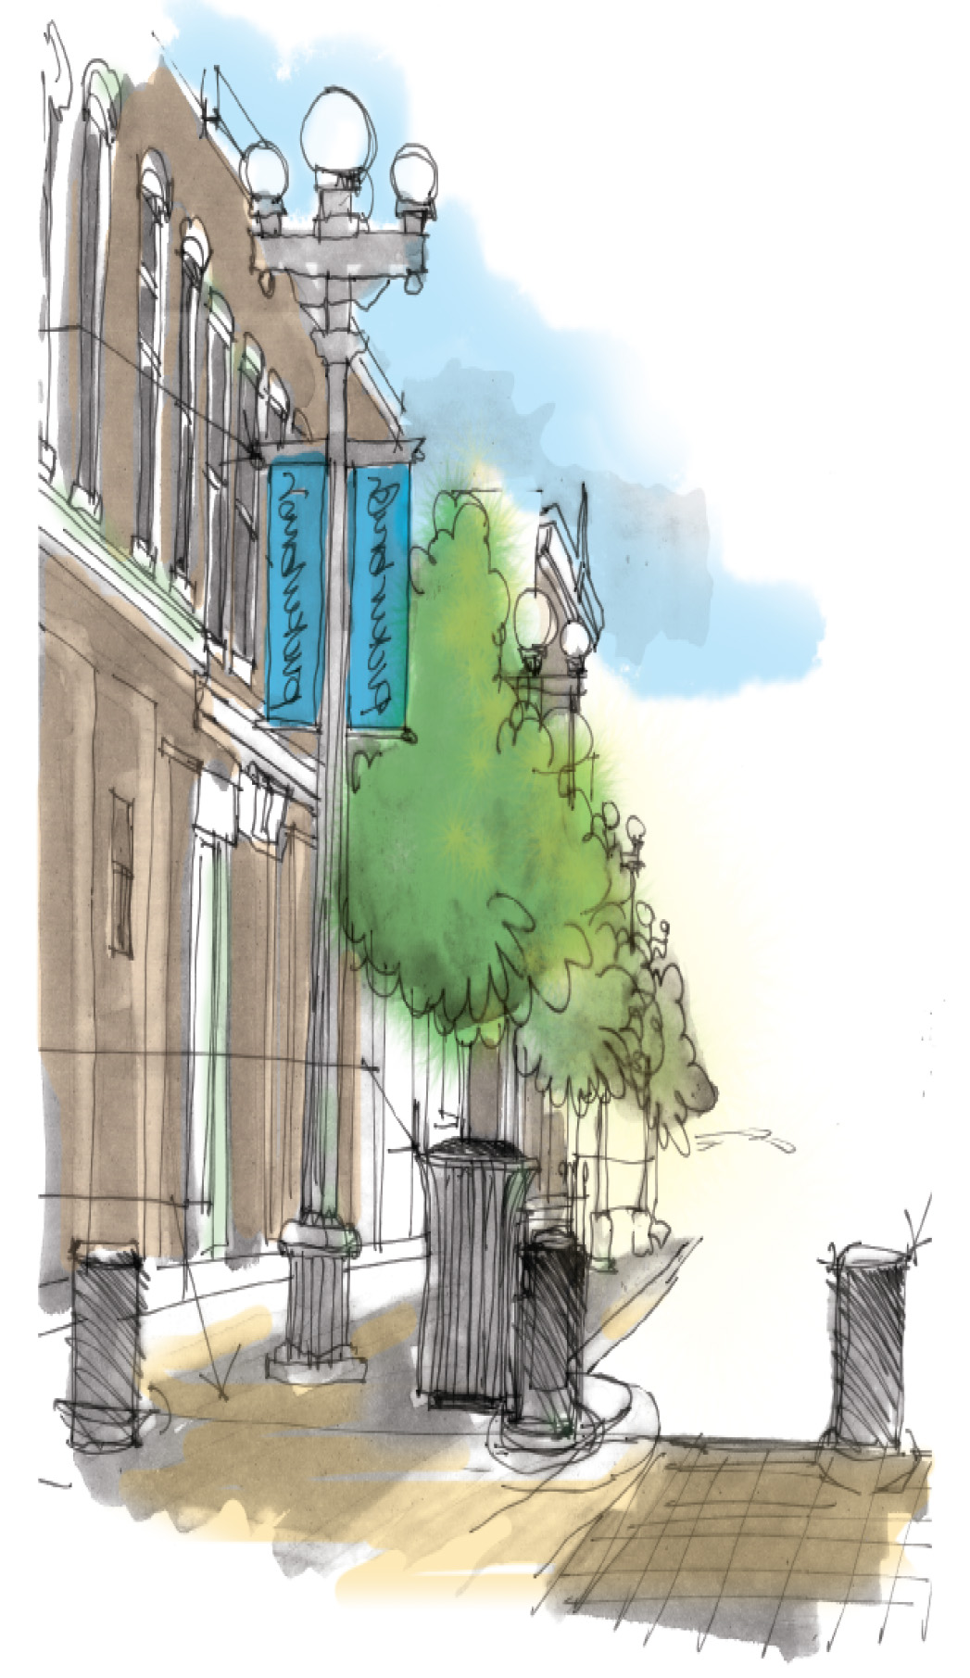
Join us for virtual focus groups…
To sign up, visit <<www.communityvisioning.org/<<CITY>>
and click on “Public Input.”
<<DATE/TIME>>: Steering Committee
<<DATE/TIME>>: Older Adults (65 years old & older)
<<DATE/TIME>>: Mobility Impaired
<<DATE/TIME>>: Actives
<<DATE/TIME>>: Parents
<<DATE/TIME>>: Youth 13 and older
<<DATE/TIME>>: Youth 12 and under

