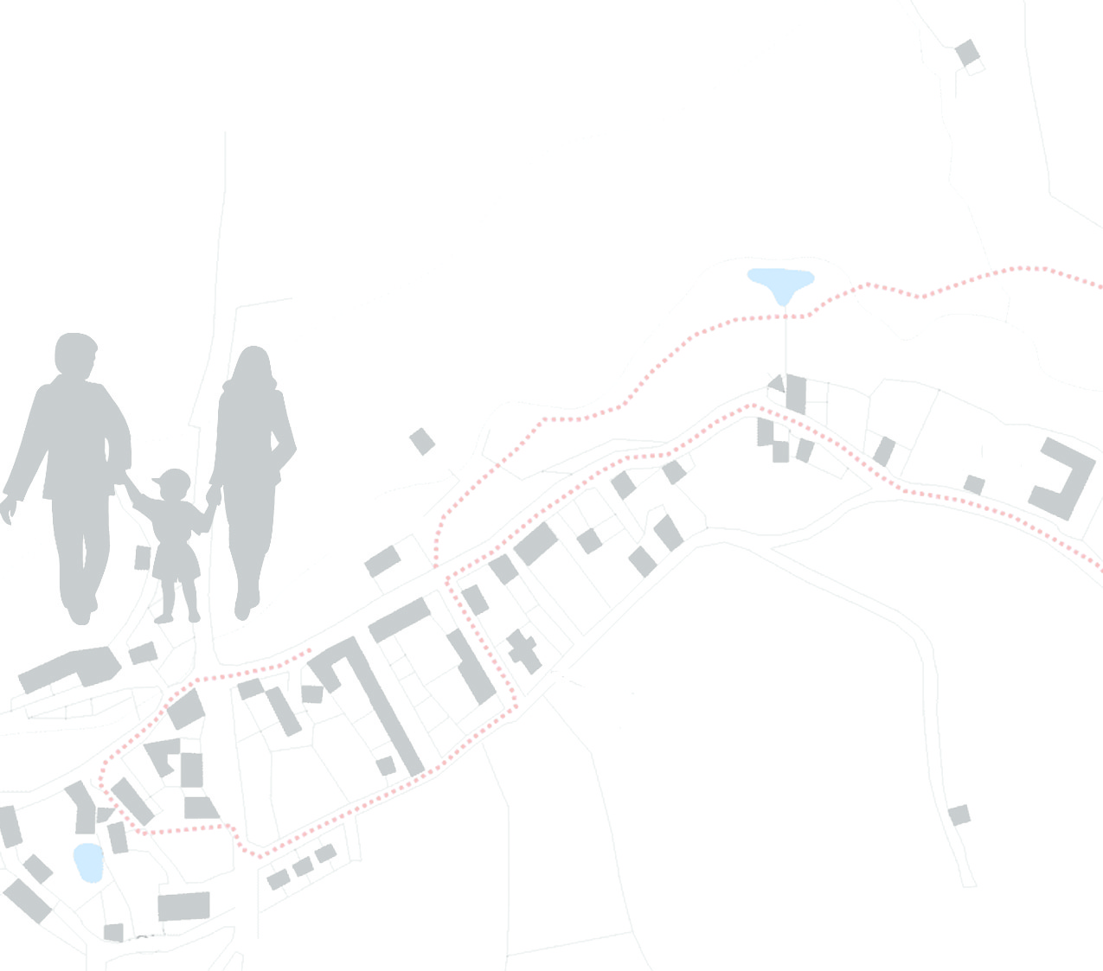
…In Designing Your Community
COMMUNITY is participating in the 2015 Community Visioning Program. Iowa State University is gathering information from community members to learn your opinions on how to improve the community’s landscape through transportation enhancements. Your input is an important part of this process and your ideas about community design and enhancement are valuable to the COMMUNITY visioning committee.

Watch your mailbox for a survey...
Iowa State University is mailing survey packets to randomly selected residents during the next week. If you receive a packet, kindly complete the questionnaire and mail it to ISU in the postage-paid envelope provided.

Other ways to become involved...
- Join the visioning committee
- Participate in program workshops
- Contact <COMMITTEE CHAIR> at <PHONE NO> to learn more

