Greene is participating in the 2017 Community Visioning Program. One of its partners, Iowa State University, is gathering information from community members to learn your opinions on how to improve the community’s landscape through transportation enhancements.
The goal of this program is to develop a landscape plan that illustrates the vision of Greene. Your input is an important part of this process and your ideas about community design and enhancement are valuable to the Greene visioning committee.
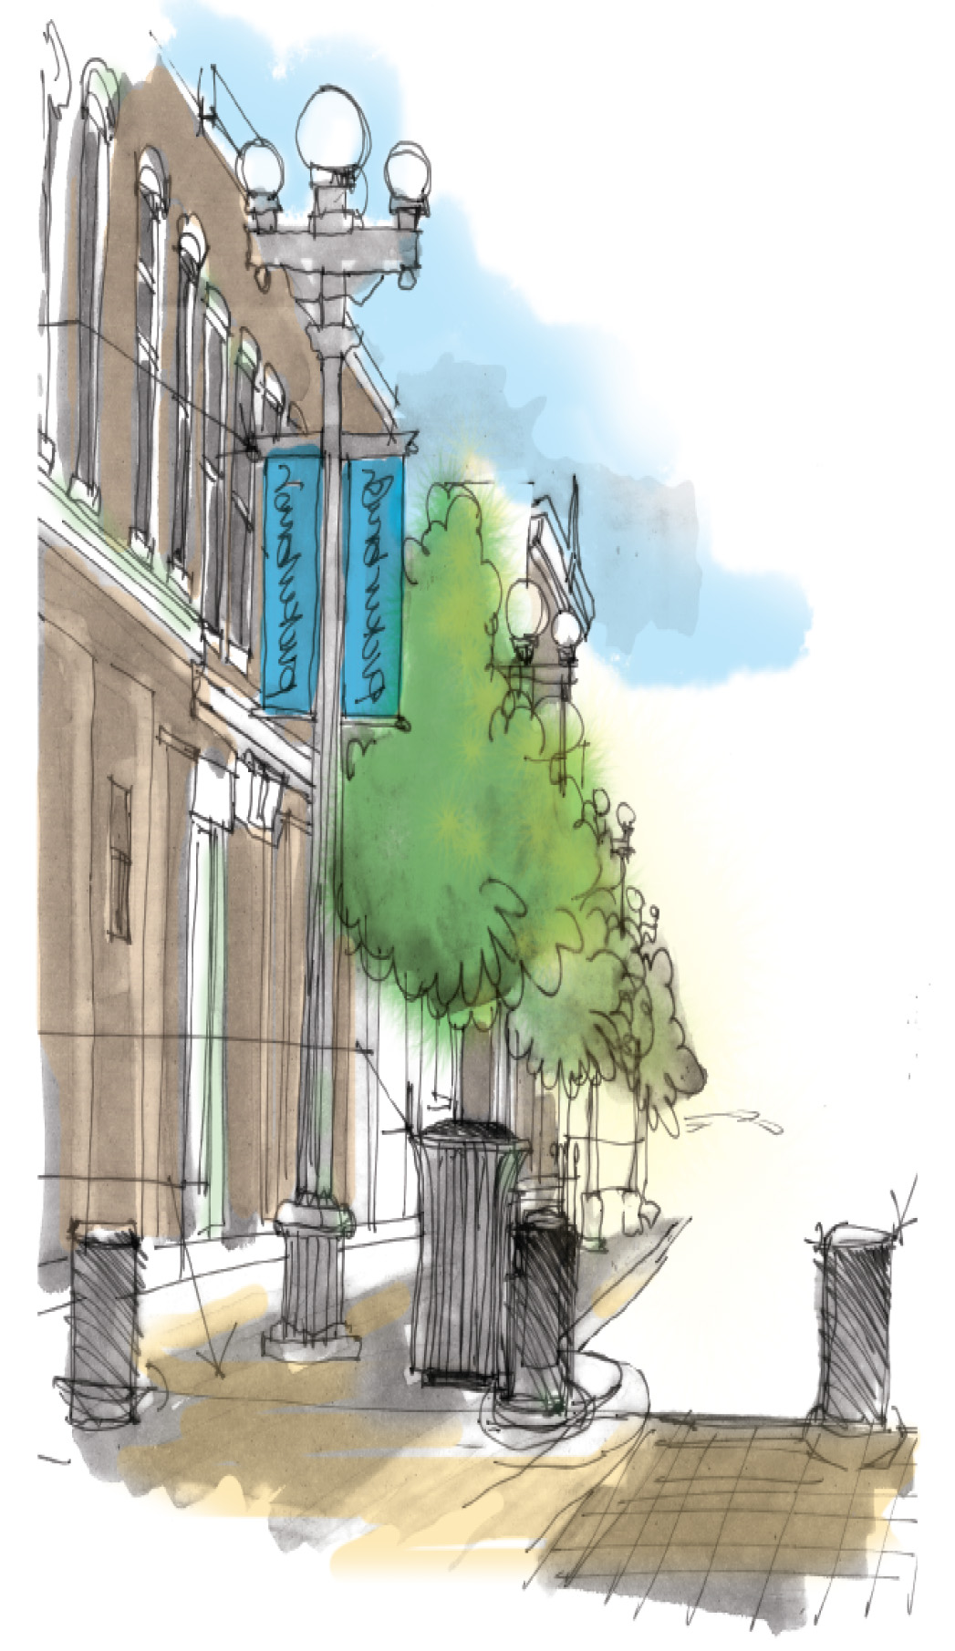
Join us for focus groups…

On Saturday, March 18 at St. Peter’s Lutheran Church

9:00- Older adults
10:00- Mobility Impaired and Active Adults
11:00- Parents and Youth
12:00- Visioning Steering Committee

At 2:30 there will be a concluding session sharing highlights from the day. All are welcome to attend. For more information contact Emily Ascher at 319-816-4849.

