<<COMMUNITY>> is participating in the 2016 Community Visioning Program. Iowa State University is gathering information from community members to learn your opinions on how to improve the community’s landscape through transportation enhancements.
The goal of this project is to develop a landscape plan that illustrates the vision of <<COMMUNITY>>. Your input is an important part of this process and your ideas about community design and enhancement are valuable to the COMMUNITY visioning committee.
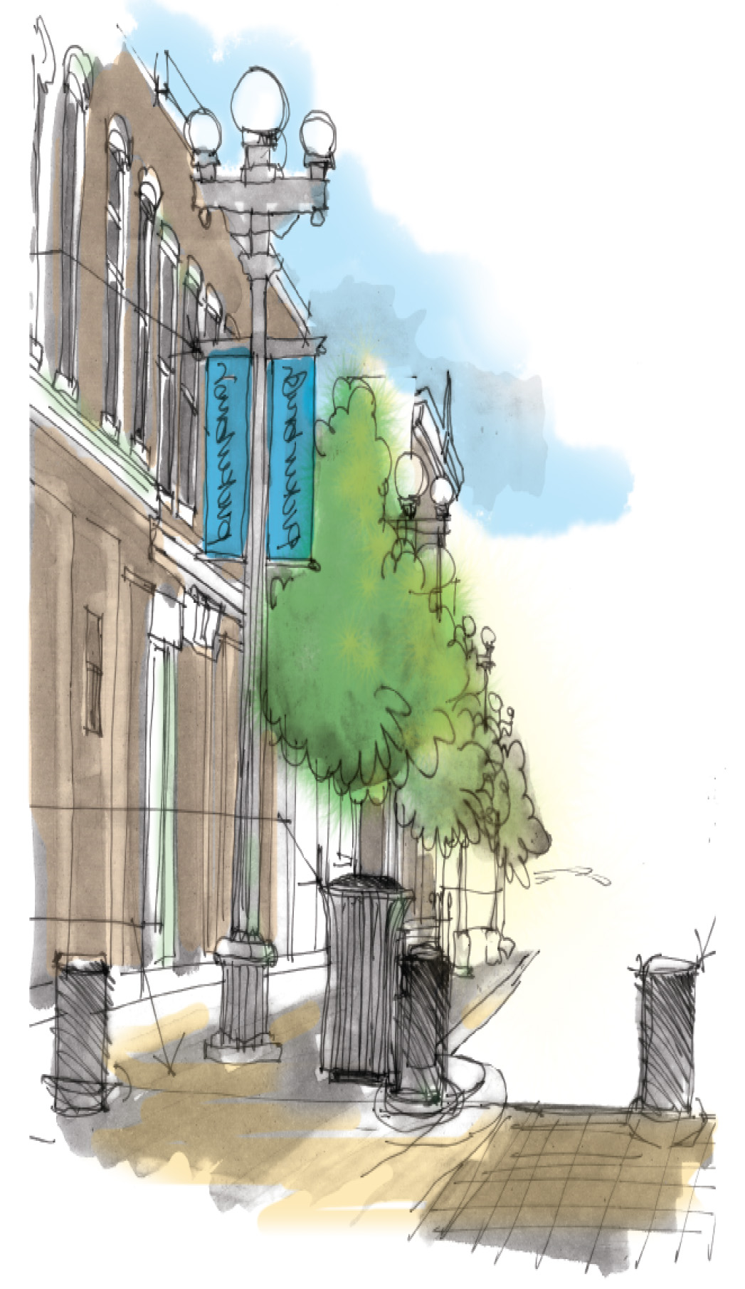
Join us for focus groups…
On <<DATE>> at the <<LOCATION>>
<<TIME>>: Steering Committee
<<TIME>>: Older Adults
<<TIME>>: Mobility Impaired
<<TIME>>: Actives
<<TIME>>: Parents and Children

