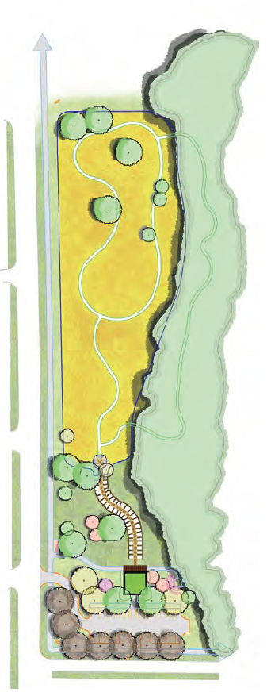
<<CITY>> is participating in this year’s Community Visioning Program. The goal of this project is to develop a landscape plan that illustrates the vision of <<CITY>>. Your input is an important part of this process and your ideas about community design and enhancement are valuable to the COMMUNITY visioning committee.

Join us for a design workshop…
A design team will be working at <<LOCATION AND ADDRESS>> throughout the workshop to develop a conceptual plan for <<CITY>>.

The public is invited to stop in between <<TIME>> and <<TIME>> to provide input on the designs. Results from focus-group workshops and the random-sample transportation survey will also be available.

