<<COMMUNITY>> is participating in the 2015 Community Visioning Program. The goal of this project is to develop a landscape plan that will graphically illustrate the vision of <<COMMUNITY>>. You are invited to see the new ideas created this summer.
Please plan to attend on <<DATE>> from <<TIME>> at <<LOCATION>>. This is your opportunity to discuss the proposed projects with local committee members, the design team, and Trees Forever staff.

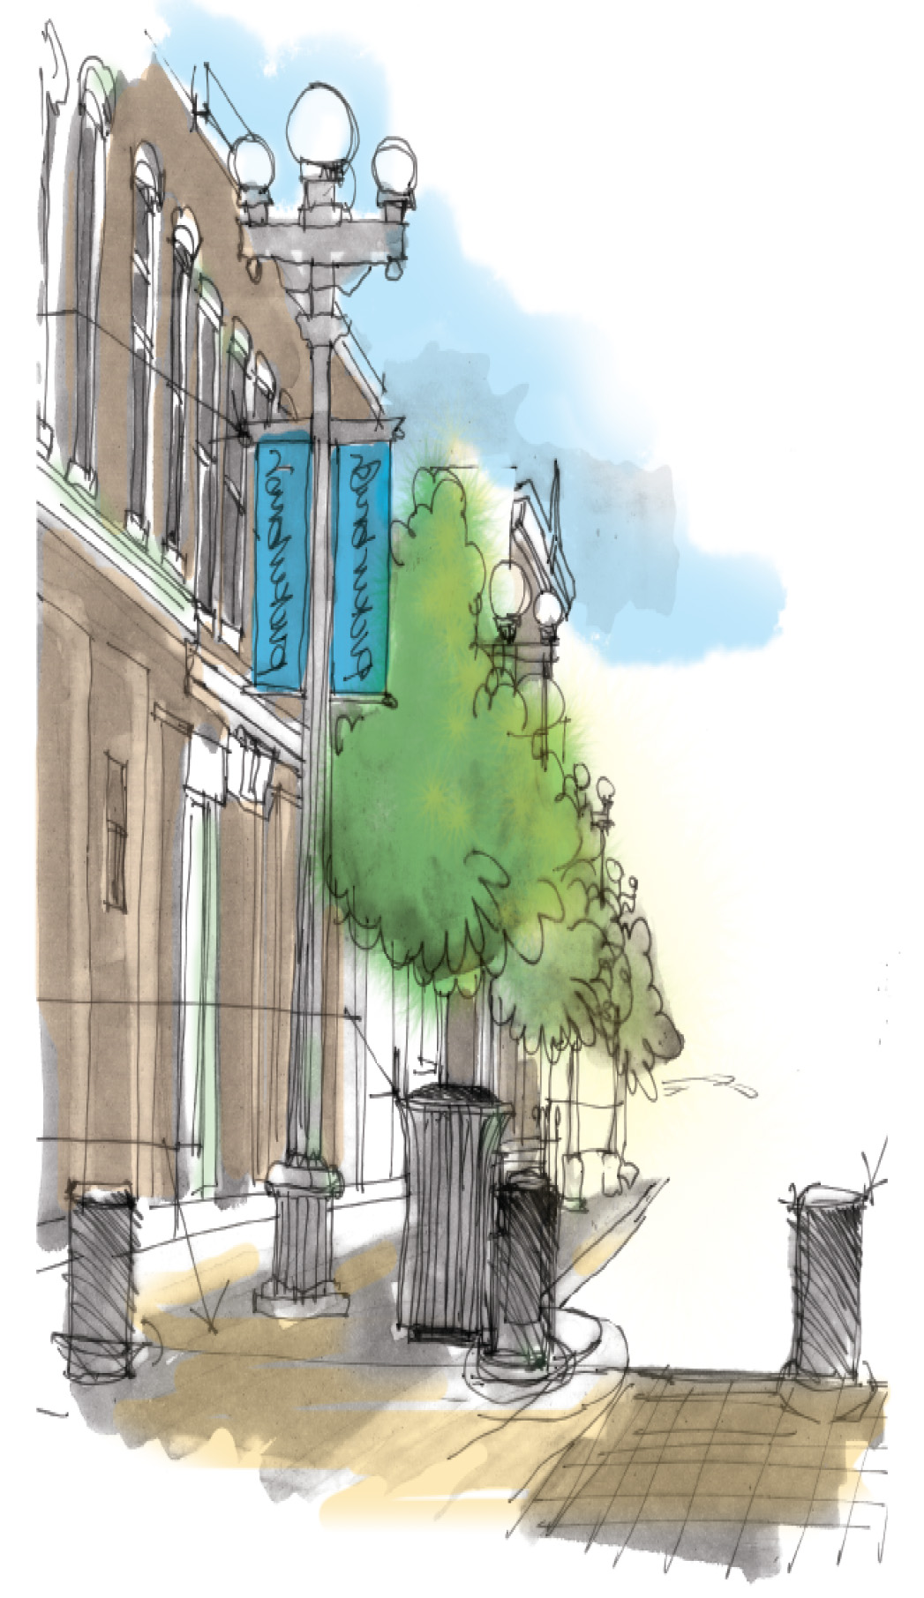
Please join us...
What: Presentation of Visioning Final Concepts
When: <<DAY OF WEEK>>, <<DATE>>, <<TIME>>
Where: <<LOCATION>>

