Wapello is participating in the 2018 Community Visioning Program. The goal of this project is to develop a landscape plan that will graphically illustrate the vision of Wapello. You are invited to see the new ideas created this summer.
Please plan to attend on Thursday, October 4 from 5:00-7:00 at the High School Cafeteria during the Volleyball games. This is your opportunity to discuss the proposed projects with local committee members, the design team, and Trees Forever staff. Designs will also be on display at other community locations at a later time.

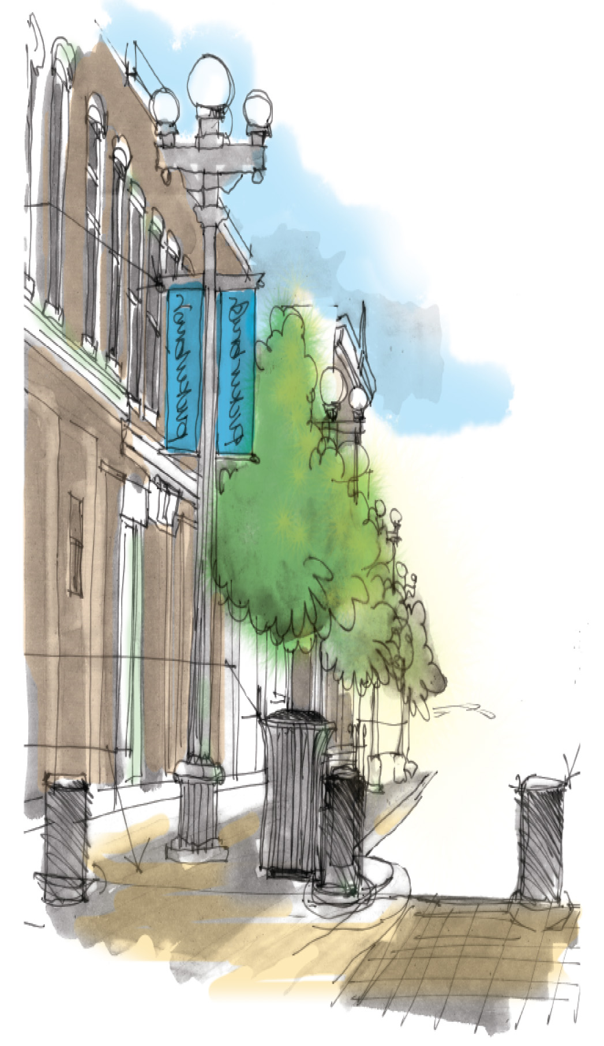
Please join us...
What: Presentation of Visioning Final Concepts
When: Thursday, October 4, 2018, 5:00-7:00
Where: Wapello High School Cafeteria

